WEEK 12
1# Write a program that calls a method that throws an exception of type ArithmeticException in a for loop at an undesirable situation (such as divide by zero or taking square root of negative number). Catch the exception and display appropriate message. (Example of Unhecked Exception).
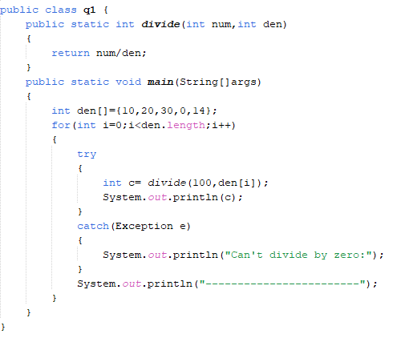
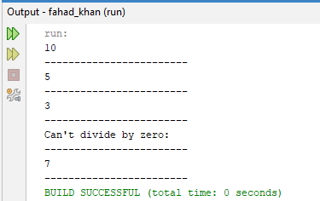
2# Write a program of your choice where a Checked Exception occurs at third function but handled at the first calling function. Use both ways of managing Checked Exception i.e. using try-catch block and throws keyword.
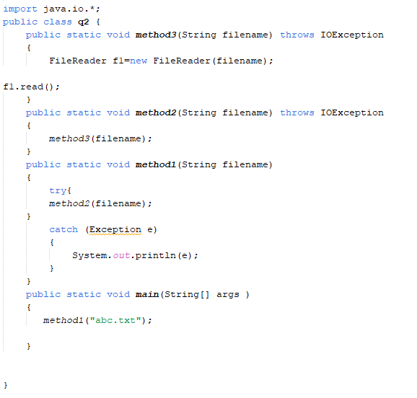
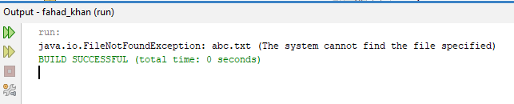
3# You are developing an online banking system where users can transfer money between accounts. If a user tries to withdraw more money than is available in their account, an InsufficientFundsException should be thrown.
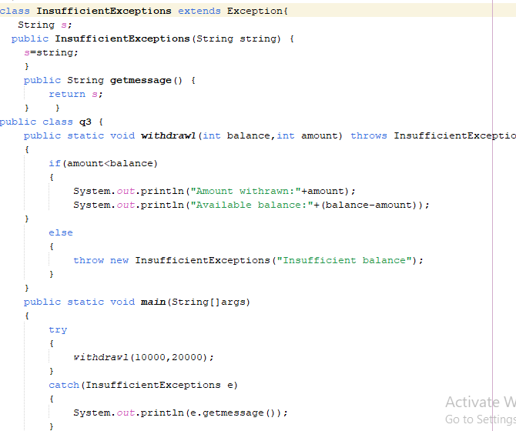
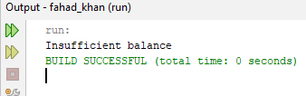
4# Create a user-defined exception InvalidAgeException when the age of a person is below 18 years. Use this exception at appropriate place.
